**EXERCISE: 03**

**DATE: 20.11.2020**

**AIM:**

To write a python program to remove and print every second number from a list of numbers until the list becomes empty

**PROGRAM:**

def removeThirdNumber(lst):

temp=[]

p=1

s=0

for i in range(0,len(lst)):

s=(p+s)%len(lst)

re=lst.pop(s)

temp.append(re)

return temp

n=int(input())

lst=[]

for i in range(0,n):

lst.append(int(input()))

p=removeThirdNumber(lst)

print(p)

**LINK:**

[**http://103.53.53.18/mod/vpl/forms/submissionview.php?id=231&userid=1697**](http://103.53.53.18/mod/vpl/forms/submissionview.php?id=231&userid=1697)

**OUTPUT:**

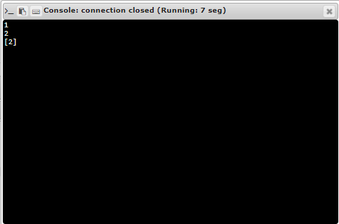

**RESULT:**

Thus the program is executed successfully